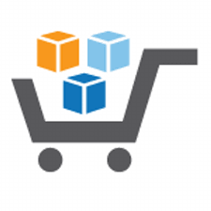

**Running an Intelligent Analytical System on AWS**

**Using AWS Services & Solutions in AWS Marketplace**

*Machine Learning and Reporting and BYOD*

Disclaimer:

1. The AWS Marketplace Fusion Solution showcased in this document is solely meant as a tutorial, *but with given additional customizations, it can be used for production use cases*.
2. Technologies used in this Solution can be replaced by other equivalent technologies as needed for business reasons.
3. All data used in this Solution is machine generated and fictitious.
4. For setting up this AWS Marketplace Fusion Solution, prior knowledge of the technologies used in the Solution and familiarity with Amazon AWS Cloud is recommended.
5. For most of the components, we used the region **US West (Oregon)**, but you can change it as per your choice.

**Table of Contents**

1. Introduction 4

2. Prerequisites 4

3. Audience 5

4. Create visualizations on TIBCO Spotfire 6

4.1. Edit Data Connection 6

4.2. Publish TIBCO Spotfire visualization file. 12

5. Integrating cloud messaging service with Kony Mobile Fabric Console 14

5.1. Setup Firebase Cloud Messaging 14

5.2. Setup Kony MobileFabric App 16

6. Install Android Notification App 23

7. Configure Web Application for sending notifications to Kony MobileFabric App. 24

* + - 1. Introduction

This document is the continuation of the Building a Data Pipeline.

In this document, you will use machine learning models to predict the occurrence of a storm in the next seven days based on historical weather data.

You will also learn how to create a predictive dashboard using **TIBCO Spotfire,** which will help end users assimilate key insights at a glance.

You will also be able to push alerts about upcoming storms to a mobile app using **Kony Mobile Fabric**. You can use the weather data source, which is already stored in Amazon Redshift.

**What you will accomplish:**

* Build a machine learning algorithm using R to predict a storm from weather data.
* Create visualizations on **TIBCO Spotfire** for storm predictions and trends in incremental stock prices.
* Push a storm prediction notification to a mobile app using **Kony Mobile Fabric**.
  + - 1. Prerequisites
  1. For this project, you need to have all the data located in Amazon Redshift.
  2. You also need to have an EC2 instance with TIBCO Spotfire up and running.
     + 1. Audience

This document is designed for different types of audiences. Therefore, each of the steps are explained in detail. Below is a list of people who are best suited to explore this document:

* Developers
* IT Managers/IT Professionals
* Data Scientists
* Mobile App Developer
  + - 1. Create visualizations on TIBCO Spotfire

4.1. Edit Data Connection

1. Make a remote desktop connection to the TIBCO Spotfire EC2 instance created in **Section 4.5.1: Launch TIBCO Spotfire Instance** of the **Deployment Guide — Part 1** in **Project 1.**
2. Launch the **TIBCO Spotfire** standalone application in the TIBCO Spotfire EC2 instance.

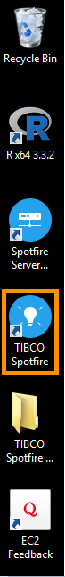

1. In the **Login** window, provide the credentials below and click on the **Login** button.

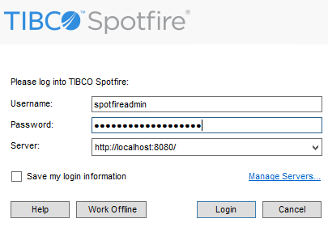

* **Username:** spotfireadmin
* **Password:** Enter the instance ID of the TIBCO Spotfire EC2 instance on which the application is launched.

1. Select **File > Open** on the drop-down menu in the TIBCO Spotfire application.

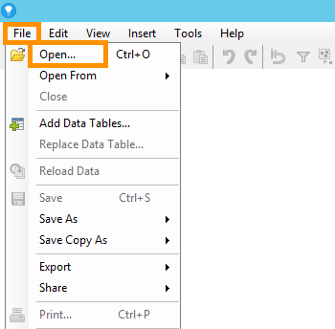

1. Navigate to the **spotfire** folder located inside the Project Directory (i.e. AmazonImmersion) (cloned during Project 2). Open the file **AWS BYOD.dxp**.

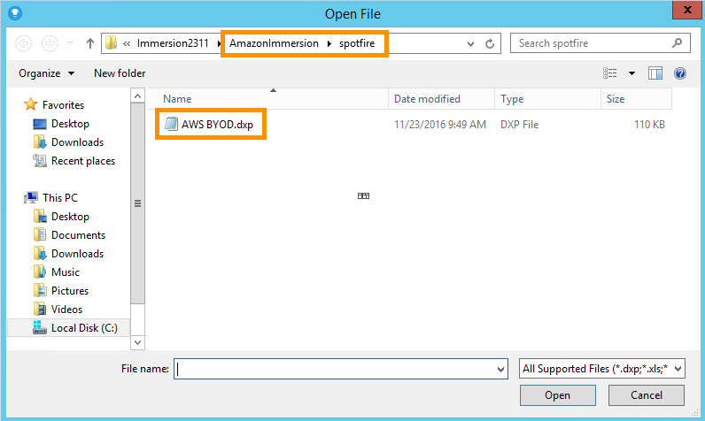

1. Click on the **Skip** button in the **Data Connection Login** window. Wait until the file opens in the application.

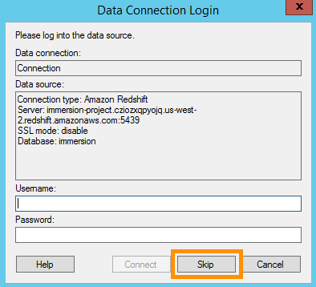

1. Now select the **Edit > Data Connection** Properties menu.

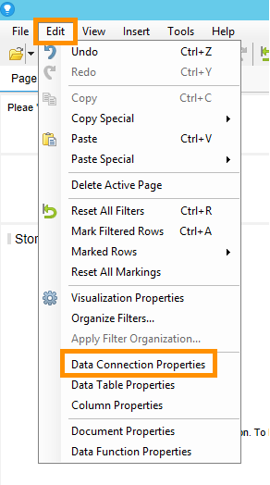

1. Keep **Connection (Embedded in analysis)** selected in the Connections list and click on the **Settings** button.

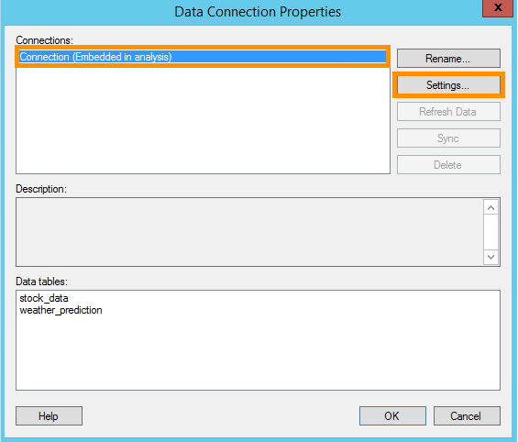

1. In the **Data Connection Settings** window, open the **Data Source** tab and click on the **Settings** button located at the bottom of the window.

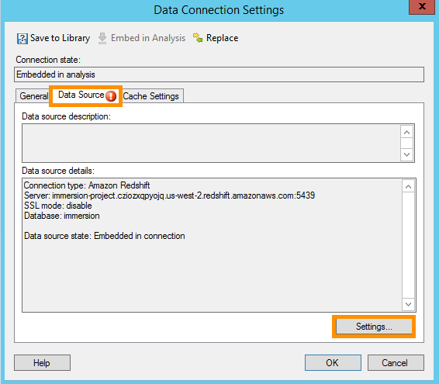

1. In the **Data Source Settings** window, in the **Login** tab, click on the **Edit** button to change the data source.

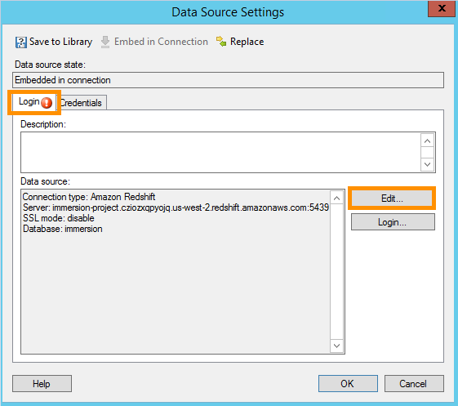

1. In the **Amazon Redshift Connection** window, enter the details below, then click on the **Connect** button at the bottom to make a connection with your Redshift cluster. You can find all these properties on the details page of your Redshift cluster.

* **Server:** Endpoint of Redshift Cluster
* **SSL mode:** disable
* **Username:** Redshift Cluster Master Username
* **Password:** Password provided while provisioning Redshift Cluster
* **Database:** Name of the database provided while provisioning Redshift Cluster

1. Click on the **OK** buttons for all opened Popup Windows.
2. Save the file by selecting **File > Save.**

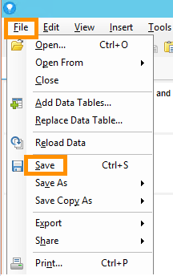

1. Close the **TIBCO Spotfire** application.

4.2. Publish TIBCO Spotfire visualization file.

1. Click on the URL “http://localhost/” in the browser of the TIBCO Spotfire EC2 Instance in order to open the **TIBCO Spotfire Web Player**.
2. Enter the following credentials to log in to the TIBCO Spotfire Web Player.

* **Username:** spotfireadmin
* **Password:** Enter the instance ID of the TIBCO Spotfire EC2 instance on which the application is launched.

1. On the home page of the TIBCO Spotfire Web Player, click on the **Open analysis** tab.

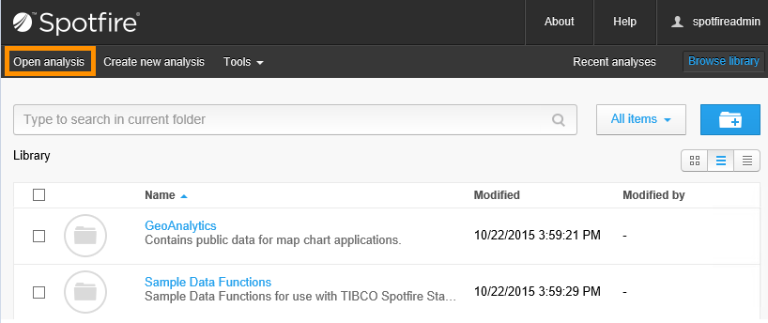

1. In the **Open Analysis** popup window, browse the TIBCO Spotfire visualization file saved in **Section** **4.1: Edit Data Connection** (i.e. AmazonImmersion\spotfire\AWS BYOD.dxp) and click on the **Open** button.

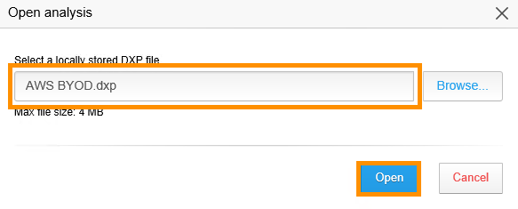

1. The **Data connection log-in** popup window will open, prompting you to provide the log-in credentials for the Redshift Cluster. Enter the same credentials of the Redshift cluster provided in **Step 11** of **Section 4.1: Edit Data Connection** and click on the **OK** button.

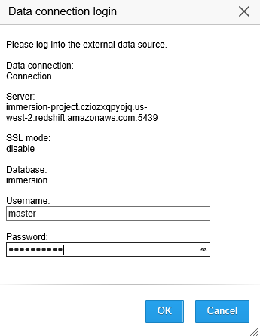

1. Now the TIBCO Spotfire visualization file gets published on the web player and it displays visualizations on the web page as shown in following image.

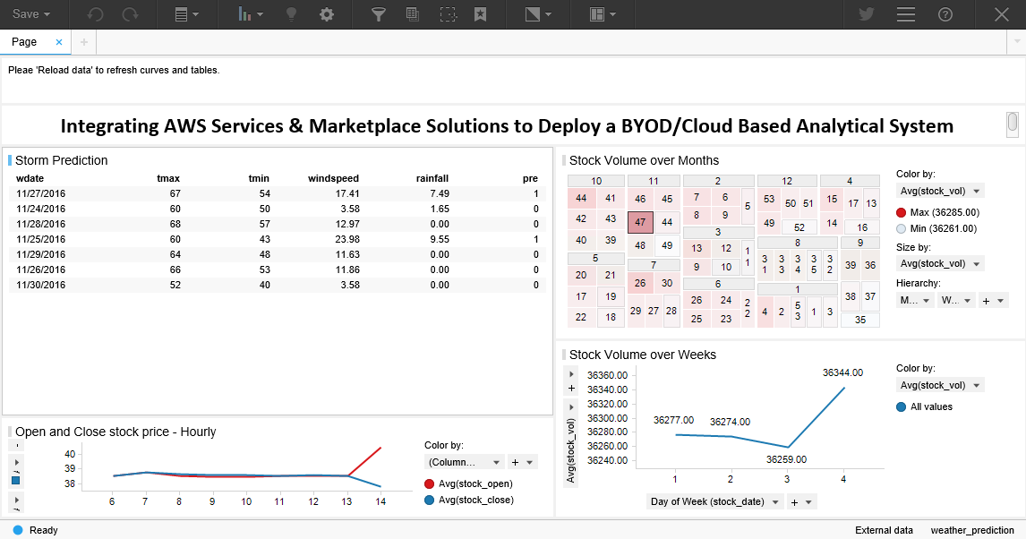

1. Integrating cloud messaging service with Kony Mobile Fabric Console

5.1. Setup Firebase Cloud Messaging

Firebase gives you the tools to develop high-quality apps. We have used **Firebase Cloud Messaging (FCM),** which is a cross-platform messaging solution that lets you reliably deliver messages at no cost.

Follow the steps below to create a new **Firebase** project:

1. Click on the URL <https://console.firebase.google.com/> in the browser of your local machine to access **Firebase**.

* Login using your Google account credentials.

1. Click on the **CREATE NEW PROJECT** button in the Firebase Console to create a new project.
2. In the **Create Project** popup window, enter a suitable **Project Name**, select an appropriate **Country,** then click on the **CREATE PROJECT** button to register the new project.
3. Click on the **Gear** icon near the project name, and select **Project settings**.

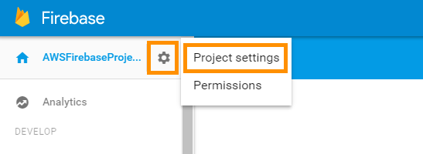

1. Select the **CLOUD MESSAGING** tab in the **Settings** window and copy the **Sender ID** and **Server key** for future steps.

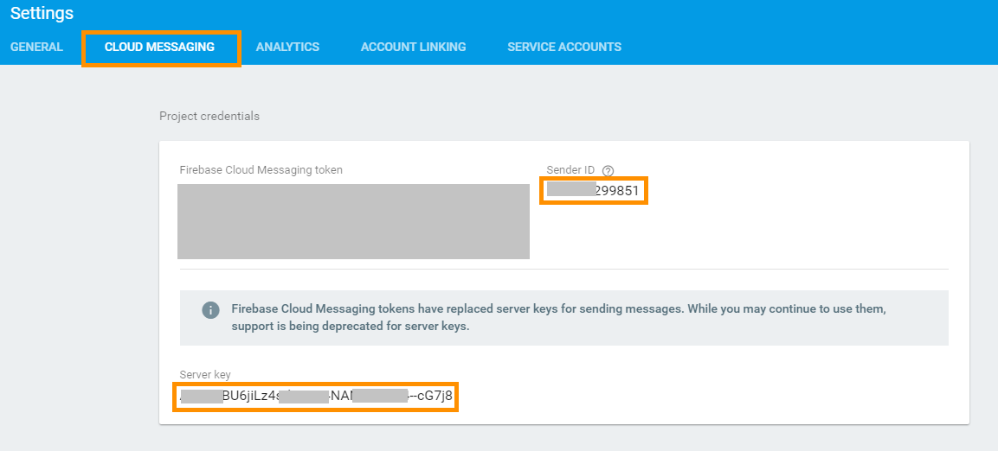

5.2. Setup Kony MobileFabric App

1. Click on the following URL in the browser of your local machine to access the **Kony MobileFabric Console.** Replace the token **<EC2-Public DNS>** with the Public DNS of the Kony MobileFabric EC2 instance that was created in **Section 4.7: Setup Kony Mobile Fabric** in the **Deployment Guide –- Part 2** of **Project 1**.

|  |
| --- |
| http://<EC2-Public DNS>:8080/mfconsole/ |

1. Enter the following credentials to login to the MobileFabric Console:

* **Email:** admin@localhost
* **Password:** M<your AWS instance id> but use '=' in place of ‘-‘. (e.g. Mi=abcd1234).

Follow the steps below to create a Kony MobileFabric app.

1. Click on the **Apps** menu on the left navigation panel and click on the **ADD NEW** button to create a new app.

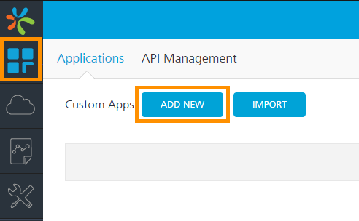

1. Click on the App name to bring up an editable field and enter an appropriate app name.

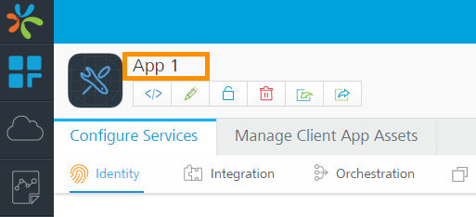

1. In the **Configure Services** tab, select the **Engagement** sub-tab. Expand **Android** to enter the details for the Firebase Cloud Messaging service for Android devices.

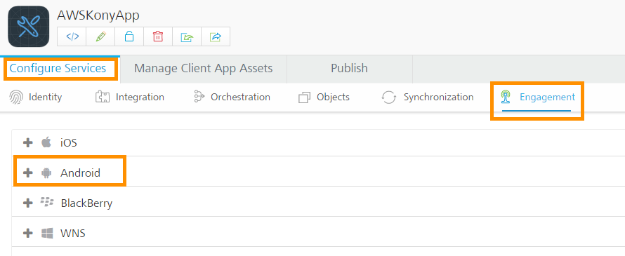

1. In the Android device tab fill in the following details and click on the **SAVE** button to register Firebase Cloud Messaging.

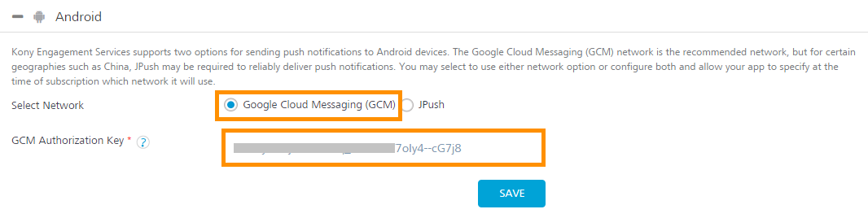

* **Select Network:** Google Cloud Messaging (GCM)
* **GCM Authentication Key:** Enter **Server key** of **Firebase Cloud Messaging**. Refer to **Step 5** of **Section 5.1: Setup Firebase Cloud Messaging.**

1. Now open the **Publish** tab and select an available environment to publish.

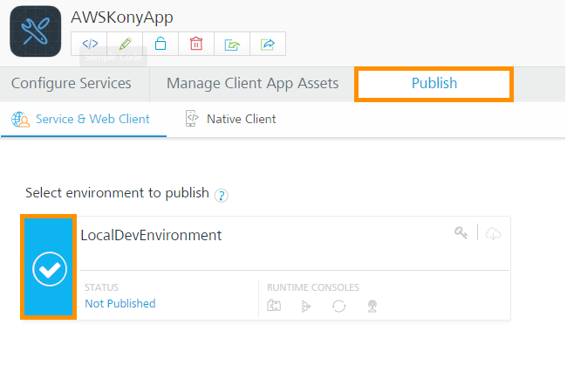

1. Click on the **Next** button and then on the **SAVE & PUBLISH** button to publish the app.
2. After a successful publishing of an environment, its status will change from **Not Published** to **Published**.

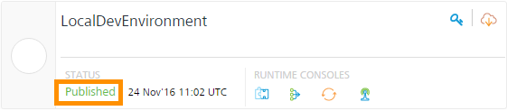

1. You can get published environments by clicking on the **Environments** menu from left navigation panel.

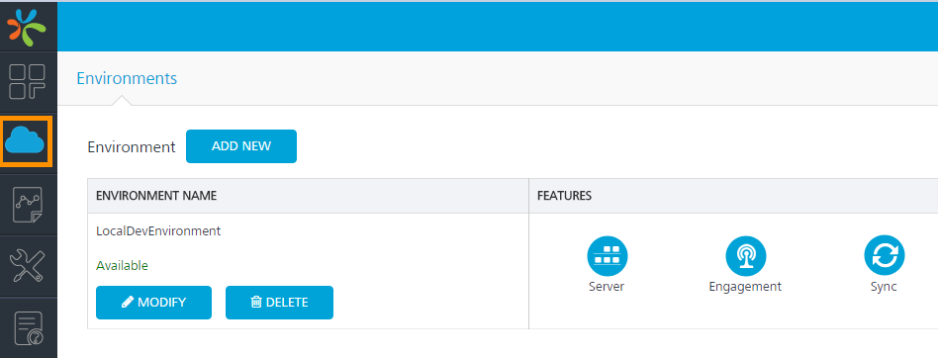

1. Click on the **Engagement** icon in the published environment window to open the Environments Dashboard.

The Environment Dashboard displays messaging statistics.

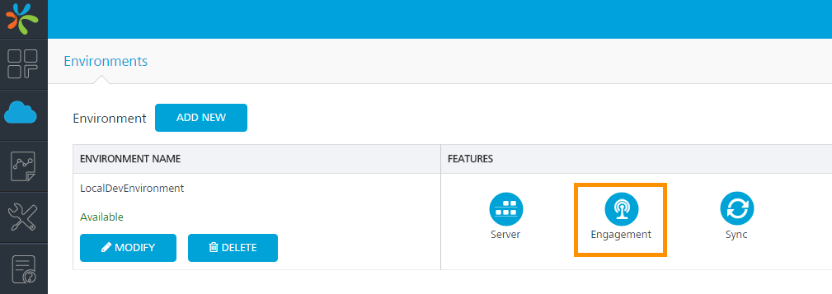

1. Click on the **Configuration** menu listed under the **Settings** header in the left navigation panel.

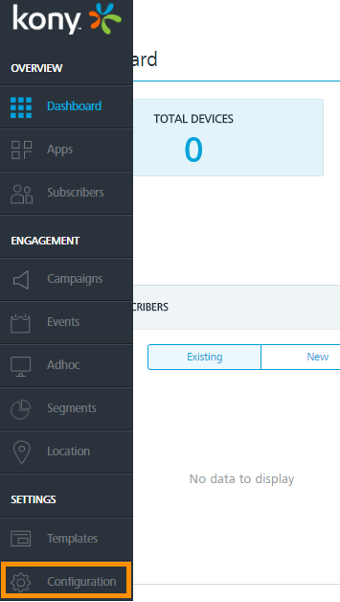

1. On the **General** tab, scroll down the page until you reach the end of the page and uncheck the **Authentication for Message API** checkbox placed under the **Security** section.

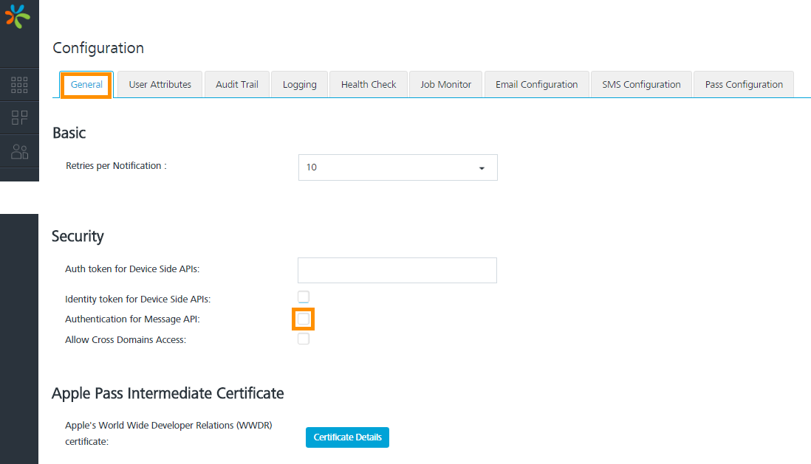

1. Click on the **Save** button to update the modified setting.
2. Click on **Apps** listed under the Overview header in the left navigation panel to get a list of Apps.

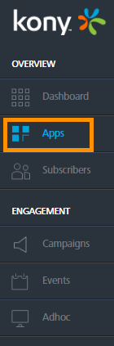

1. Copy the **App Id** of your desired app for future steps. The location of the App ID is highlighted in the image below.

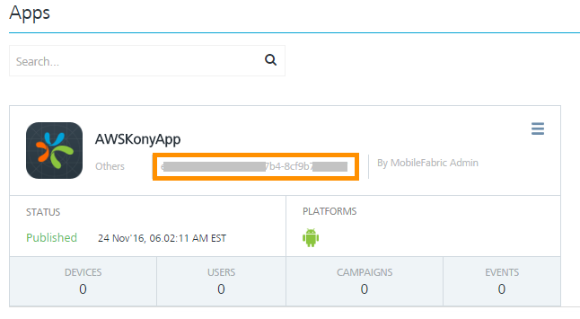

1. Click the **API Help** menu listed under the **SETTINGS** header on the left navigation panel.

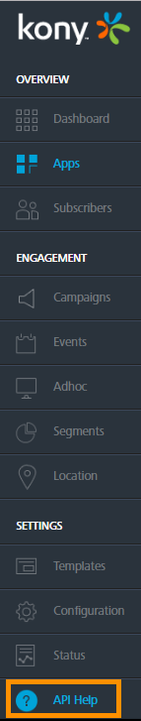

1. Select the **Message** tab on the **API Help** page and copy the **Push Message URL** for future use.

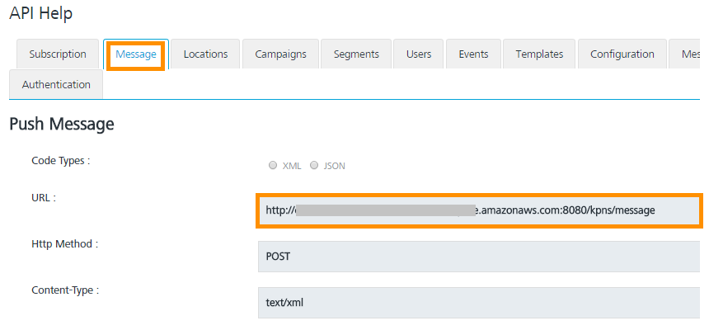

1. Install Android Notification App
2. Install the Android Notification App on your Android device by using the Android Installation file (**awsbyod.apk**), placed in the **AndroidApp** folder of the Project Directory (AmazonImmersion), (Cloned in the TIBCO Spotfire instance.)
3. Enter the following properties in the installed Android App and click on **DONE** to successfully receive notifications.

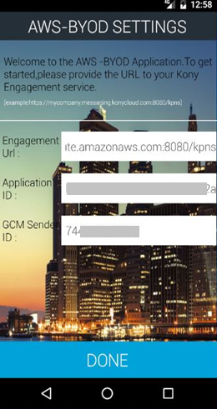

* **Engagement URL:** Enter the following URL. However, replace token **<EC2_Public DNS>** with the Public DNS of Kony MobileFabric EC2 instance.

**http://<EC2_Public DNS>:8080/kpns**

* **Application ID:** Enter the Kony MobileFabric App ID obtained in **Step 16** of **Section 5.2.**
* **GCM Sender ID:** Enter the Firebase Cloud Messaging Services App ID obtained in **Step 5** of **Section 5.1: Setup Firebase Cloud Messaging.**

Your Android device is now ready to receive storm forecast notifications sent by the AWS BYOD app.

1. Configure Web Application for sending notifications to Kony MobileFabric App.

**Note:** Before executing the following, make sure you have completed all the steps in Project 2.

1. Make a remote desktop connection to the **TIBCO Spotfire** instance.
2. Stop the **Tomcat server** on the TIBCO Spotfire instance, if it was running.
3. Open the **webapps** folder located in the **Tomcat installation directory.** (i.e. C:\Program Files\Apache Software Foundation\Tomcat 8.5\webapps)
4. Navigate to the **AmazonByod > WEB-INF > classes** folder and open the **ProjectConf.properties** file to update the settings for the Kony MobileFabric app.
5. Replace the following tokens in the properties file and **save** it.

* **<KONY_URL>:** Replace this token with the **Push Messaging URL** of the **Kony MobileFabric App** obtained in **Step 18** of **Section 5.2**.
* **<KONY_APP_ID>:** Replace this token with the **Kony MobileFabric App ID** obtained in **Step 16** of **Section 5.2.**

**Note:** If any component instance used in a project is restarted, then update the properties file accordingly.

1. Now run the **Tomcat executable** file (TomcatX.exe, where X is the version number) to start the Tomcat server. It is located inside the **bin** directory of the Tomcat installation directory (i.e. C:\Program Files\Apache Software Foundation\Tomcat 8.5\bin).
2. After a successful initiation of the Tomcat Server click on the URL below to access the **AmazonBYOD** web app.

|  |
| --- |
| <http://localhost:8088/AmazonByod/> |

1. Click on the **Start** button on the **Step 5: Storm Prediction** tab to start the prediction and send a storm forecast notification to the **Kony MobileFabric** app.

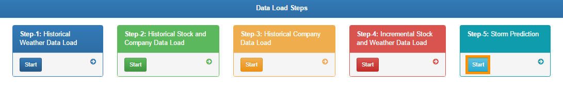

1. Now, whenever the system forecasts a storm prediction, you will receive a notification on the Android device as shown in following image:

